**TPS Usecases**

**Project Name: Transaction Processing System**

**Project ID: N/A**

**Executive Sponsor: Jojo Industrial Sales**

**Project Manager: Kyle Zelig Tieng**

**Business Analyst: Team Dunno**

Date: August 12, 20142014

**Table of Contents**

Approvals 6

Use Case List 7

**1. Process Supply 7**

Feature Process Flow / Use Case Model 7

1.1 Order Form 7

1.2 Transfer Slip 8

**2. Check Stock 9**

Feature Process Flow / Use Case Model 9

2.1 Inventory Checking 9

2.2 Supply Request 10

**3. Process Supply 11**

Feature Process Flow / Use Case Model 11

3.1 Supply Form 11

3.2 Supply Update 12

3.3 Warehouse Storage 12

**4. Deliver Item 13**

Feature Process Flow / Use Case Model 13

4.1 Acquisition of items 13

4.2 Issue Receipt 14

Revision History

| **Version** | **Date** | **Revision Description** |
| --- | --- | --- |
| .01 | 8/12/14 | First Draft |
|  |  |  |
|  |  |  |
|  |  |  |
|  |  |  |
|  |  |  |
|  |  |  |

# Approvals

We have carefully assessed the Use Cases for this project. This document has been completed in accordance with the requirements of the System Development Methodology.

MANAGEMENT CERTIFICATION - Please check the appropriate statement.

______ the document is accepted.

______ the document is accepted pending the changes noted.

______ the document is not accepted.

We fully accept the changes as needed improvements and authorize initiation of work to proceed. Based on our authority and judgment, the continued operation of this system is authorized.

(*=Required **= Submit for Review Approval Not Required)

Executive Sponsor** DATE

Project Sponsor* DATE

Quality Assurance Manager / Team Lead* DATE

Business Analyst Manager / Team Lead* DATE

Project Manager DATE

# Use Case List

|  |  |  |
| --- | --- | --- |
| **Use Case ID** | **Primary Actor** | **Use Cases** |
| 1.1 | Client | ORDER FORM |
| 1.2 | Secretary | TRANSFER SLIP |
| 2.1 | Accountant | INVENTORY CHECKING |
| 2.2 | Manager | SUPPLY REQUEST |
| 3.1 | Manager | SUPPLY FORM |
| 3.2 | Accountant | SUPPLY UPDATE |
| 3.3 | Manager | WAREHOUSE STORAGE |
| 4.1 | Secretary | ACQUISITION OF ITEMS |
| 4.2 | Accountant | ISSUE RECEIPT |

## 1. Process Supply

## Feature Process Flow / Use Case Model

## 

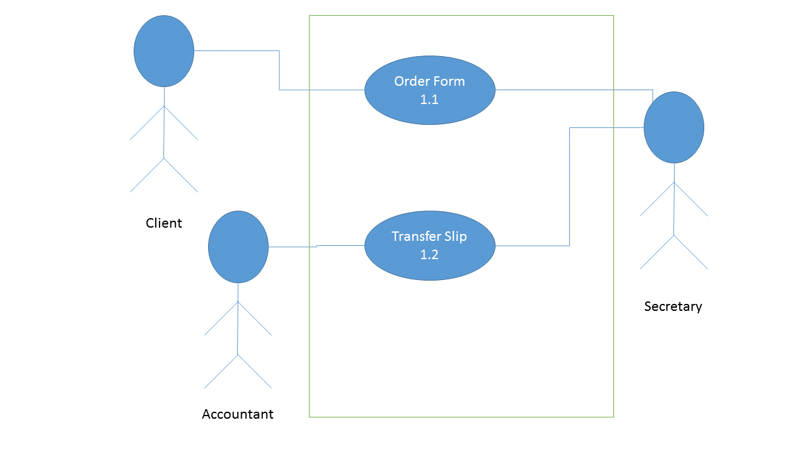

## 1.1 Order Form

|  |  |  |  |  |
| --- | --- | --- | --- | --- |
| **Use Case ID:** | 1.1 | | | |
| **Use Case Name:** | Receipt | | | |
| **Created By:** | Carlo Montenegro | | **Last Updated By:** | Carlo Montenegro |
| **Date Created:** | 8/12/14 | | **Last Revision Date:** | 8/12/14 |
| **Actors:** | | Client (primary); Secretary (secondary) | | |
| **Description:** | | An order form is sent filled up by the client | | |
| **Trigger:** | | A client fills up an order form | | |
| **Preconditions:** | | 1. A client acquires an order form | | |
| **Postconditions:** | | 1. An order is accomplished | | |
| **Normal Flow:** | | 1. A customer gets the necessary form from the secretary  2. The customer fills up the order form and specifies his or her requirements | | |
| **Alternative Flows:** | | None | | |
| **Exceptions:** | | None | | |
| **Includes:** | | None | | |
| **Frequency of Use:** | | Depends on frequency of customers | | |
| **Special Requirements:** | | None | | |
| **Assumptions:** | | None | | |
| **Notes and Issues:** | | None | | |



## 1.2 Transfer Slip

|  |  |  |  |  |
| --- | --- | --- | --- | --- |
| **Use Case ID:** | 1.2 | | | |
| **Use Case Name:** | Transfer Slip | | | |
| **Created By:** | Carlo Montenegro | | **Last Updated By:** | Carlo Montenegro |
| **Date Created:** | 8/12/14 | | **Last Revision Date:** | 8/12/14 |
| **Actors:** | | Secretary (primary); Accountant (secondary) | | |
| **Description:** | | The secretary sends a transfer slip to the warehouse | | |
| **Trigger:** | | A client gives the secretary an order form | | |
| **Preconditions:** | | 1. An order form is completely and validly filled up | | |
| **Postconditions:** | | 1. The warehouse receives the transfer slip | | |
| **Normal Flow:** | | 1. The secretary checks if the order form is valid  2. The secretary completes a transfer slip containing the request(s) specified in the order form  3. The secretary sends the transfer slip to the warehouse, via an accountant | | |
| **Alternative Flows:** | | None | | |
| **Exceptions:** | | 1. The order form is not validly filled up | | |
| **Includes:** | | None | | |
| **Frequency of Use:** | | Depends on frequency of customers | | |
| **Special Requirements:** | | None | | |
| **Assumptions:** | | None | | |
| **Notes and Issues:** | | None | | |



## 2. Check Stock

## Feature Process Flow / Use Case Model

## 

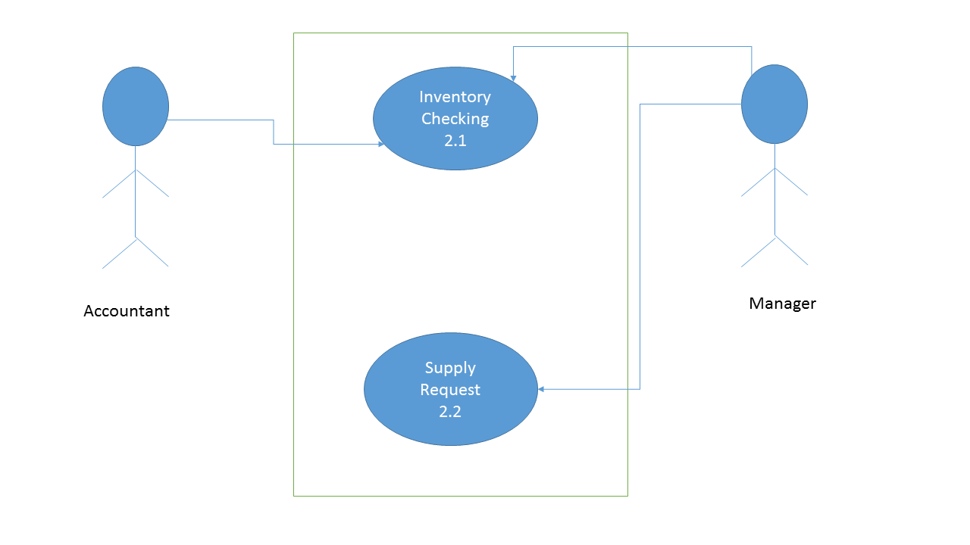

## 2.1 Inventory Checking

|  |  |  |  |  |
| --- | --- | --- | --- | --- |
| **Use Case ID:** | 2.1 | | | |
| **Use Case Name:** | Inventory Checking | | | |
| **Created By:** | Niccolo Enriquez | | **Last Updated By:** | Carlo Montenegro |
| **Date Created:** | 8/12/2014 | | **Last Revision Date:** | 8/12/2014 |
| **Actors:** | | Accountant (primary); Manager (secondary) | | |
| **Description:** | | Inventory is checked to answer a delivery | | |
| **Trigger:** | | An order is met and/or Accountant wants to check the inventory | | |
| **Preconditions:** | | None | | |
| **Postconditions:** | | 1. Inventory is sufficient for the order  2. Inventory is insufficient for the order | | |
| **Normal Flow:** | | 1. Accountant checks transfer slip  2. Accountant checks inventory  3. Accountant proceeds to fulfill the customer's request | | |
| **Alternative Flows:** | | a. When checking inventory for an order  1. Accountant checks transfer slip  2. Accountant checks inventory  3. Inventory is insufficient so account proceeds to order from supplier  b. When checking inventory for regular inventory(v)  1. Accountant checks inventory  2. Account orders from supplier | | |
| **Exceptions:** | | None | | |
| **Includes:** | | None | | |
| **Frequency of Use:** | | Daily | | |
| **Special Requirements:** | | None | | |
| **Assumptions:** | | The lack of inventory for an order is not considered an error | | |
| **Notes and Issues:** | | None | | |

## 2.2 Supply Request

|  |  |  |  |  |
| --- | --- | --- | --- | --- |
| **Use Case ID:** | 2.2 | | | |
| **Use Case Name:** | Supply Request | | | |
| **Created By:** | Niccolo Enriquez | | **Last Updated By:** | Carlo Montenegro |
| **Date Created:** | 8/12/2014 | | **Last Revision Date:** | 8/12/2014 |
| **Actors:** | | Manager (primary) | | |
| **Description:** | | Manager fill outs a purchase order form to request supplies from the Supplier | | |
| **Trigger:** | | Manager wants to request for supplies | | |
| **Preconditions:** | | None | | |
| **Postconditions:** | | 1. Purchase Order form is accomplished | | |
| **Normal Flow:** | | 1. Manager requisitions a Purchase Order form  2. Form is filled out | | |
| **Alternative Flows:** | | None | | |
| **Exceptions:** | | None | | |
| **Includes:** | | None | | |
| **Frequency of Use:** | | [for designer] | | |
| **Special Requirements:** | | None | | |
| **Assumptions:** | | Manager, when he decides to order, has no reason to suddenly decide not to | | |
| **Notes and Issues:** | | Frequency of use is yet to be determined | | |

## 3. Process Supply

## Feature Process Flow / Use Case Model

## C:\Users\QueenieJoy\AppData\Local\Microsoft\Windows\INetCache\Content.Word\3.png

## 3.1 Supply Form

|  |  |  |  |  |
| --- | --- | --- | --- | --- |
| **Use Case ID:** | 3.1 | | | |
| **Use Case Name:** | Supply Form | | | |
| **Created By:** | Niccolo Enriquez | | **Last Updated By:** | Carlo Montenegro |
| **Date Created:** | 8/12/2014 | | **Last Revision Date:** | 8/12/2014 |
| **Actors:** | | Manager (primary); Supplier (secondary) | | |
| **Description:** | | Allows manager to get the order from the Supplier in the system | | |
| **Trigger:** | | Supplier has items (w/ Supply Form) to give as requested | | |
| **Preconditions:** | | 1. There is a request for supplies | | |
| **Postconditions:** | | 1. Supply Form will be received the manager | | |
| **Normal Flow:** | | 1. Supplier gives Supply Form  2. Manager receives Supply Form | | |
| **Alternative Flows:** | | 3.1 Get Order from Supply Form  1. Manager requests for Supply Form  2. Supplier gives Supply Form  3. Manager receives Supply Form | | |
| **Exceptions:** | | None | | |
| **Includes:** | | None | | |
| **Frequency of Use:** | | [for designer] | | |
| **Special Requirements:** | | None | | |
| **Assumptions:** | | None | | |
| **Notes and Issues:** | | Frequency of use is yet to be determined | | |

## 3.2 Supply Update

|  |  |  |  |  |
| --- | --- | --- | --- | --- |
| **Use Case ID:** | 3.2 | | | |
| **Use Case Name:** | Supply Update | | | |
| **Created By:** | Niccolo Enriquez | | **Last Updated By:** | Carlo Montenegro |
| **Date Created:** | 8/12/2014 | | **Last Revision Date:** | 8/12/2014 |
| **Actors:** | | Accountant (primary); Manager (secondary) | | |
| **Description:** | | Accountant updates supply | | |
| **Trigger:** | | Accountant wants to update supply | | |
| **Preconditions:** | | None | | |
| **Postconditions:** | | 1. Supply is updated | | |
| **Normal Flow:** | | 1. Manager gives Accountant the Supply Form  2. Accountant updates Supply | | |
| **Alternative Flows:** | | 3.2. Input Items to Supply  1. Accountant requests for Supply Form  2. Manager gives Accountant the Supply Form  3. Accountant updates Supply | | |
| **Exceptions:** | | None | | |
| **Includes:** | | 2.1. Inventory Checking | | |
| **Frequency of Use:** | | [for designer] | | |
| **Special Requirements:** | | None | | |
| **Assumptions:** | | None | | |
| **Notes and Issues:** | | Frequency of use is yet to be determined | | |

## 3.3 Warehouse Storage

|  |  |  |  |  |
| --- | --- | --- | --- | --- |
| **Use Case ID:** | 3.3 | | | |
| **Use Case Name:** | Warehouse Storage | | | |
| **Created By:** | Niccolo Enriquez | | **Last Updated By:** | Carlo Montenegro |
| **Date Created:** | 8/12/2014 | | **Last Revision Date:** | 8/12/2014 |
| **Actors:** | | Manager (primary) | | |
| **Description:** | | Goods are transferred to the warehouse | | |
| **Trigger:** | | Manager requests that goods have to be transferred to the warehouse | | |
| **Preconditions:** | | None | | |
| **Postconditions:** | | 1. Items are stored in the Warehouse  2. Items are damaged during storage | | |
| **Normal Flow:** | | 1. Manager requests items to be stored  2. Workers store items into the Warehouse  3. Manager validates that the items have been stored | | |
| **Alternative Flows:** | | None | | |
| **Exceptions:** | | If item(s) are destroyed  1. Manager logs that item(s) was/were damaged during storage | | |
| **Includes:** | | None | | |
| **Frequency of Use:** | | [for designer] | | |
| **Special Requirements:** | | None | | |
| **Assumptions:** | | None | | |
| **Notes and Issues:** | | Frequency of use is yet to be determined | | |

## 4. Deliver Item

## Feature Process Flow / Use Case Model

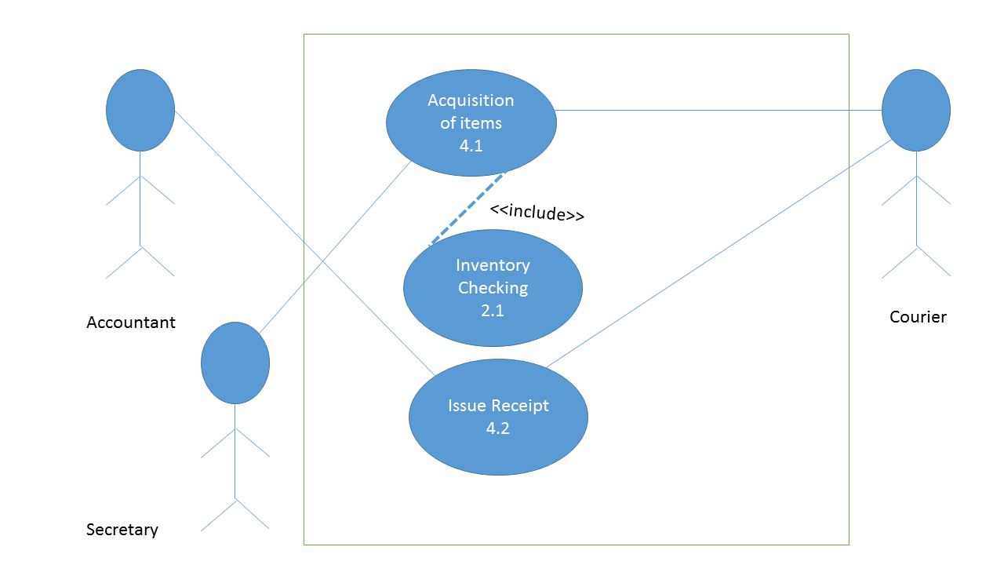

## 4.1 Acquisition of items

|  |  |  |  |  |
| --- | --- | --- | --- | --- |
| **Use Case ID:** | 4.1 | | | |
| **Use Case Name:** | Acquisition of items | | | |
| **Created By:** | Kyle Tieng | | **Last Updated By:** | Kyle Tieng |
| **Date Created:** | 8/12/14 | | **Last Revision Date:** | 8/12/14 |
| **Actors:** | | Secretary (primary); Courier (secondary) | | |
| **Description:** | | Ready the item/s to be delivered to the Client | | |
| **Trigger:** | | There is no shortage of the item/s to be delivered | | |
| **Preconditions:** | | 1. The Client has already ordered some item/s | | |
| **Postconditions:** | | 1. The item/s are ready to be delivered | | |
| **Normal Flow:** | | 1. Secretary checks the order form of the Customer 2. Secretary makes an “Items for Delivery List” and hands it to the Courier 3. Courier fetches the items from the warehouse 4. Secretary and Courier double checks items on the list 5. Items await delivery | | |
| **Alternative Flows:**  **[Alternative Flow 1 – Not in Network]** | | 3.1 Items are out of stock  1. Order additional stocks from the Supplier.  2. Go through the Process Supply use case  3. Once the stocks have been replenished, repeat step 3. | | |
| **Exceptions:** | | 3.1.1 Supplier is also out of stock  1. If the supplier doesn’t have any stock as well, order will be canceled | | |
| **Includes:** | | 2.1 Inventory Checking | | |
| **Frequency of Use:** | | [for designer] | | |
| **Special Requirements:** | | None | | |
| **Assumptions:** | | None | | |
| **Notes and Issues:** | | None | | |

## 4.2 Issue Receipt

|  |  |  |  |  |
| --- | --- | --- | --- | --- |
| **Use Case ID:** | 4.2 | | | |
| **Use Case Name:** | Issue Receipt | | | |
| **Created By:** | Kyle Tieng | | **Last Updated By:** | Kyle Tieng |
| **Date Created:** | 8/12/14 | | **Last Revision Date:** | 8/12/14 |
| **Actors:** | | Accountant (primary); Courier (secondary) | | |
| **Description:** | | Give the client its receipt, and also deliver the items the client ordered. | | |
| **Trigger:** | | Once the items are ready to be delivered and everything has been double checked. | | |
| **Preconditions:** | | 1. Items are ready to be delivered | | |
| **Postconditions:** | | 1. The Client receives the items and the receipt | | |
| **Normal Flow:** | | 1. The Accountant makes a receipt that will accompany the goods to be given to the Client 2. The items and the receipt are gathered by the Courier. 3. The Courier sends the items to the Client 4. The Client receives the items and the receipt | | |
| **Alternative Flows:** | | None | | |
| **Exceptions:** | | None | | |
| **Includes:** | | None | | |
| **Frequency of Use:** | | [for designer] | | |
| **Special Requirements:** | | None | | |
| **Assumptions:** | | None | | |
| **Notes and Issues:** | | None | | |